Raw sewage and its treatment

|  |  |  |  |
| --- | --- | --- | --- |
| Symbol | meaning | equation | default |
| Q | Sewage flow |  | 0.2 |
| SO | Mass of sewage solids |  | 0.09 |
| BOD |  |  | 0.06 |
| FB | Fraction BOD in sewage solids |  | 0.5417 |
| FS | Fraction sewage solids removed by primary settler |  | 0.667 |
| focs | Fraction organic carbon in sewage solids |  | 0.3 |
| ds | Density of sewage solids |  | 1.5 |
| Cso,s | Conc. solids in raw sewage | $${SO}/Q$$ | 0.45 |
| CBOD,S | Conc. BOD in raw sewage | $${BOD}/Q$$ | 0.3 |

Defining the primary clarifier

|  |  |  |  |
| --- | --- | --- | --- |
| Symbol | meaning | equation | default |
| hps | Depth of the PS tank |  | 4 |
| HRTPS | Hydraulic retention time |  | 2 |
| VOLPS | Volume PS per person |  | 1.67∙10-2 |
| AREAPS | Area PS per person |  | 4.167∙10-3 |
| CSO,PS | Conc. suspended solids in PS | (1-FS) ∙ Cso,s | 0.15 |
| FP | Fraction BOD removed by PS | FS∙FB | 0.36 |

Defining the activated sludge process

|  |  |  |  |
| --- | --- | --- | --- |
| Symbol | meaning | equation | default |
| hAS=hSLS | Depth of aeration tank and SLS |  | 3 |
| HRTSLS | Hydraulic retention time SLS |  | 6 |
| CSO,AS | Conc. suspended solids in activated sludge |  | 4 |
| CSO,SLS | Conc. suspended solids in effluent |  | 0.0075 |
| dAS | Density of activated sludge solids |  | 1.3 |
| focAS | Fraction organic carbon activated sludge |  | 0.37 |
| kSLR | Sludge loading rate |  | 0.1 |
| M | Aeration mode: surface (s) or bubble (b) |  | s |
| OxReq | Oxygen requirement | $$(1-FP)⋅\frac{BOD}{Q}$$ | 0.192 |
| VOLAS | Volume aerator per person |  | 9.6∙10-2 |
| AREAAS | Area aerator per person |  | 3.2∙10-2 |
| HRTAS | Hydraulic retention time  aerator | $$\frac{{VOL}_{AS}}{Q}⋅24$$ | 11.5 |
| VOLSLS | Volume SLS per person |  | 5.0∙10-2 |
| AREASLS | Area SLS per person |  | 1.67∙10-2 |

|  |  |  |  |
| --- | --- | --- | --- |
| Symbol | meaning | equation | default |
| FBODrem | Fraction BOD removed in activated sludge  process | $$F_{\text{BODrem }}=0.818-0.0422⋅ln⁡k_{SLR}$$ | 0.915 |
| YBOD | Sludge growth | $$Y_{\text{BOD }}=0.947-0.0739⋅ln⁡k_{SLR}$$ | 0.777 |
| SU | Wasted sludge (surplus sludge) | $$SU=Q⋅\left(\text{ OxReq }⋅F_{\text{BODrem }}⋅Y_{BOD}-C_{\text{so,SLS }}\right)$$ | 0.026 |
| SRT | sludge retention time | $$SRT=\frac{{VOL}_{AS}⋅C_{SO,AS}}{SU+C_{SO,SLS}⋅Q}=\frac{1}{k_{SLR}⋅F_{BODrem}⋅Y_{BOD}}$$ | 14.1 |

Definition of the modelled chemical

Equilibrium partitioning constants

|  |  |  |  |
| --- | --- | --- | --- |
| Symbol | meaning | equation | default |
| SOS | Chemical concentration in sewage solids (raw and settled) |  |  |
| SOAS | Chemical concentration in activated sludge solids |  |  |
| W | Chemical concentration in water |  |  |
| A | Chemical concentration in air |  |  |
| KAW | Air-water equilibrium partition constant | $$\frac{A}{W}$$ |  |
| Kps | Sewage solids-water equilibrium partition constant | $$\frac{{SO}_{S}}{W}$$ |  |
| KpAS | Activated sludge solids-water equilibrium partition  constant | $$\frac{{SO}_{AS}}{W}$$ |  |

$$H=\frac{P⋅MW}{W}=R⋅T⋅K_{AW}$$

Henry’s law constant, H, has dimensions of Pa∙m3∙mol-1. P is the vapour pressure in Pascal (Pa) of the chemical in equilibrium with the aqueous concentration W, MW is the molecular weight of the chemical in g∙mol-1, R is the gas constant (8.314 J∙K-1∙1R -1) and T is the absolute temperature (K). KAW is also known as the dimensionless Henry constant.

Estimation methods for equilibrium partitioning constants

Neutral organic chemicals

From base-set data (Table 12) the air-water equilibrium partition coefficients of organic chemicals is estimated according to:

$$K_{AW}=\frac{H}{R⋅T}=\frac{VP⋅\frac{MW}{SOL}}{R⋅T}$$

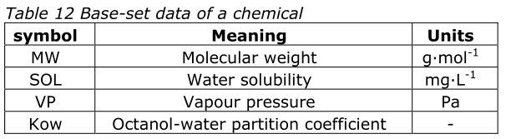

For the partitioning of the chemical between solids and the aqueous phase, a simple relationship is applied:

$$Kp=foc⋅Koc$$

With：

Kp: partition coefficients [L∙kg-1] for sewage (KpS) or activated sludge (KpAS)

Koc: partition coefficient for organic [L∙kg-1]

foc: fraction organic carbon solids, focS =0.3 or focAS =0.37[-]

$$Koc=1.26⋅{Kow}^{0.81}$$

Organic acids and bases

$$Fn=\frac{1}{1+{10}^{γ}⋅(pH-pKa)}$$

In the case of acids, γ equals 1 and, in the case of bases, γ is -1

$$K_{AW}=\frac{H}{R⋅T}⋅Fn=\frac{VP⋅\frac{MW}{SOL}}{R⋅T}⋅Fn$$

$$\begin{aligned}&\text{ Dow }=\frac{C_{n}^{0}+C_{\text{ion }}^{o}}{C_{n}^{W}+C_{\text{ion }}^{W}}= \\ &=Fn⋅\frac{C_{n}^{0}}{C_{n}^{W}}+(1-Fn)⋅\frac{C_{\text{ion }}^{0}}{C_{\text{ion }}^{W}}= \\ &=Fn⋅\text{ Kow }+(1-Fn)⋅\text{ Kow (ionized) }≅Fn⋅Kow\end{aligned}$$

Chemical fate processes

Mass balance equations

$$\begin{aligned}&\text{ box }1:C_{1}⋅\left({XCH}_{1,2}+{XCH}_{1,5}+{XCH}_{1,7}+{ADV}_{1,0}\right)-C_{2}⋅{XCH}_{2,1}-C_{5}⋅{XCH}_{5,1}-C_{7}⋅{XCH}_{7,1}=0 \\ &\text{ box }2:C_{1}⋅{XCH}_{1,2}-C_{2}⋅\left({XCH}_{2,1}+{XCH}_{2,3}+{ADV}_{2,5}\right)+C_{3}⋅{XCH}_{3,2}=-C(0,2)⋅{ADV}_{0,2} \\ &\text{ box }3:C_{2}⋅{XCH}_{2,3}-C_{3}⋅\left({XCH}_{3,2}+{ADV}_{3,6}+{ADV}_{3,4}\right)=-C(0,3)⋅{ADV}_{0,3} \\ &\text{ box }4:C_{3}⋅{ADV}_{3,4}-C_{4}⋅{ADV}_{4,0}=0 \\ &\text{ box 5: }C_{1}⋅{XCH}_{1,5}+C_{2}⋅{ADV}_{2,5}-C_{5}⋅\left({XCH}_{5,1}+{XCH}_{5,6}+{ADV}_{5,7}+k_{5}⋅V_{5}\right)+C_{6}⋅{XCH}_{6,5}=0 \\ &\text{ box 6: }C_{3}⋅{ADV}_{3,6}+C_{5}⋅{XCH}_{5,6}-C_{6}⋅\left({XCH}_{6,5}+{ADV}_{6,8}\right)+C_{9}⋅{ADV}_{9,6}=0 \\ &\text{ box }7:C_{1}⋅{XCH}_{1,7}+C_{5}⋅{ADV}_{5,7}-C_{7}⋅\left({XCH}_{7,1}+{XCH}_{7,8}+{ADV}_{7,0}\right)+C_{8}⋅{XCH}_{8,7}=0 \\ &\text{ box 8: }C_{6}⋅{ADV}_{6,8}+C_{7}⋅{XCH}_{7,8}-C_{8}⋅\left({XCH}_{8,7}+{ADV}_{8,0}+{ADV}_{8,9}\right)=0 \\ &\text{ box }9:C_{8}⋅{ADV}_{8,9}-C_{9}⋅\left({ADV}_{9,6}+{ADV}_{9,0}\right)=0\end{aligned}$$

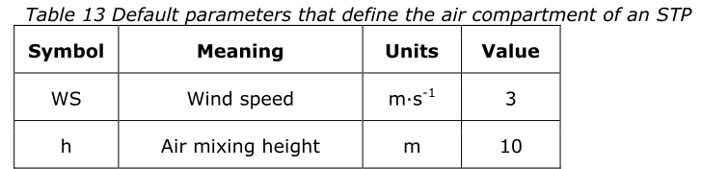

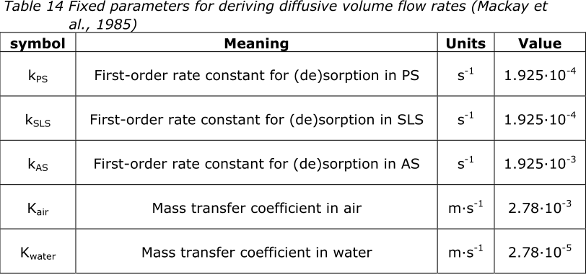

Table A1 Volumes of the nine boxes per inhabitant

|  |  |  |
| --- | --- | --- |
| Vi | Equation | default value  (m3∙PE-1) |
| V1 |  | 0.53 |
| V2 |  | 1.6710-2 |
| V3 |  | 1.67∙10-6 |
| V4 |  | 4.17∙10-5 |
| V5 |  | 9.58∙10-2 |
| V6 |  | 2.95∙10-4 |
| V7 |  | 5.0∙10-2 |
| V8 |  | 2.88∙10-7 |
| V9 |  | 1.67∙10-5 |

|  |  |  |
| --- | --- | --- |
| ADVi,j | Equation | default value |
| ADV0,1 |  | 6.9 m3∙s-1∙PE-½ |
| ADV1,0 |  | 6.9 m3∙s-1∙PE-½ |
| ADV0,2 |  | 2.31∙10-6 m3∙s-1∙PE-1 |
| ADV2,5 |  | 2.31∙10-6 m3∙s-1∙PE-1 |
| ADV5,7 |  | 2.31∙10-6 m3∙s-1∙PE-1 |
| ADV7,0 |  | 2.31∙10-6 m3∙s-1∙PE-1 |
| ADV0,3 |  | 6.94∙10-10 m3∙s-1∙PE-1 |
| ADV3,4 |  | 4.63∙10-10 m3∙s-1∙PE-1 |
| ADV3,6 |  | 2.31∙10-10 m3∙s-1∙PE-1 |
| ADV4,0 |  | 4.63∙10-10 m3∙s-1∙PE-1 |
| ADV6,8 |  | 7.12∙10-9 m3∙s-1∙PE-1 |
| ADV8,0 |  | 1.34∙10-11 m3∙s-1∙PE-1 |
| ADV8,9 |  | 7.11∙10-9 m3∙s-1∙PE-1 |
| ADV9,0 |  | 2.29∙10-10 m3∙s-1∙PE-1 |
| ADV9,6 |  | 6.88∙10-9 m3∙s-1∙PE-1 |
| Sludge decay |  | 2.44∙10-11 m3∙s-1∙PE-1 |

|  |  |
| --- | --- |
| XCHi,j | Equation |
| XCH1,2 |  |
| XCH2,1 |  |
| XCH2,3 |  |
| XCH3,2 |  |
| XCH1,5 |  |
| XCH5,1 |  |
| XCH5,6 |  |
| XCH6,5 |  |
| XCH1,7 |  |
| XCH7,1 |  |
| XCH7,8 |  |
| XCH8,7 |  |

Output

Emission to air

The fraction of the chemical emitted to air (Eair) by an STP of the size of N inhabitants is:

$$E_{\text{air }}=3600⋅24⋅\frac{C_{1}⋅{ADV}_{1,0}⋅\sqrt{N}}{1000⋅E}$$

E: Emission rate of the chemical

Emission to water

The total concentration (CT in mg∙L-1) in effluent discharged into the receiving water body is:

$$C_{T}=C_{7}+C_{8}⋅\frac{C_{\text{SO,SLS }}}{1000⋅d_{AS}}$$

The fraction (Eeff) of the chemical input that leaves an STP serving N inhabitants via effluent is:

$$E_{eff}=\frac{C_{T}⋅Q⋅N}{1000⋅E}$$

Emission via combined sludge

The concentration in combined sludge (Ccs in mg/kg dry weight) equals

$$\begin{aligned}E_{\text{sludge }}&=\frac{C_{4}⋅{ADV}_{4,0}+C_{9}⋅{ADV}_{9,0}}{1000⋅E}⋅N \\ &=\frac{\frac{FS⋅SO}{1000⋅d_{RS}}⋅C_{4}+\frac{SU}{1000⋅d_{AS}}⋅C_{9}}{1000⋅E}⋅N\end{aligned}$$